Observations:

1. Under the skills field its allowing to select multiple skills by dragging the cursor.

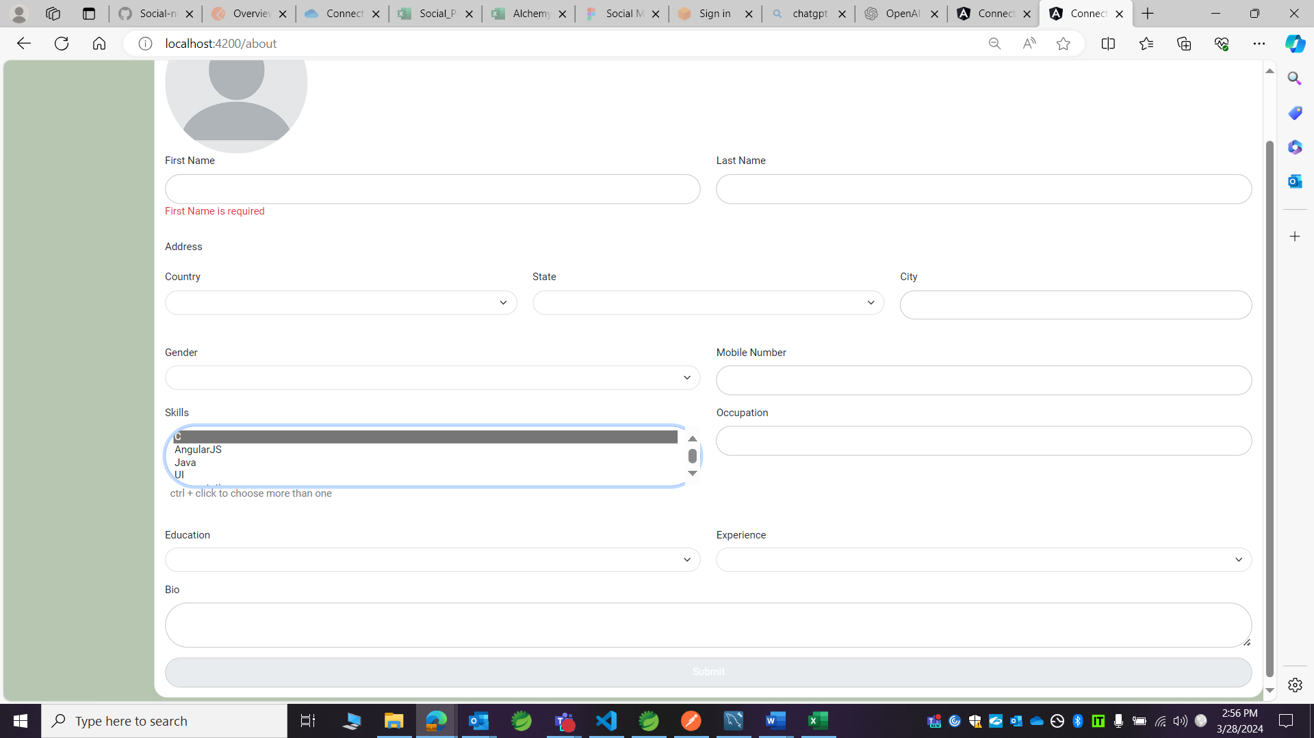

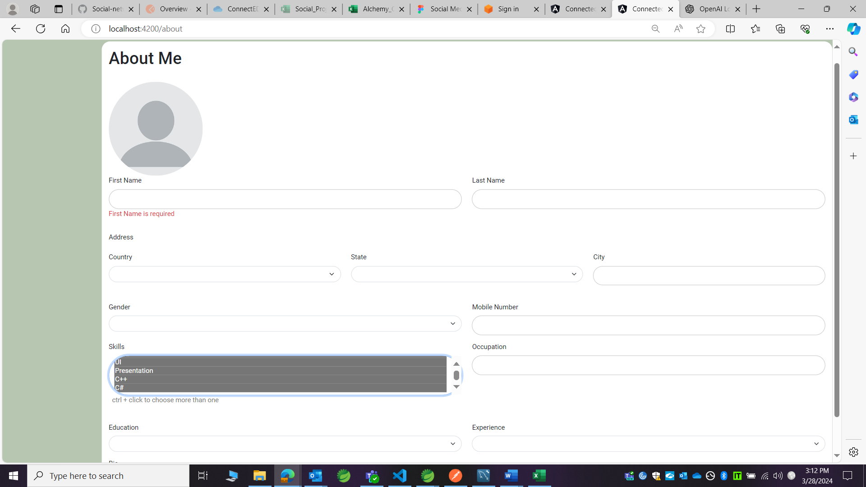

1. Under the skills field, when scrolling down, the scroll option at the RHS is not moving as we scroll down.



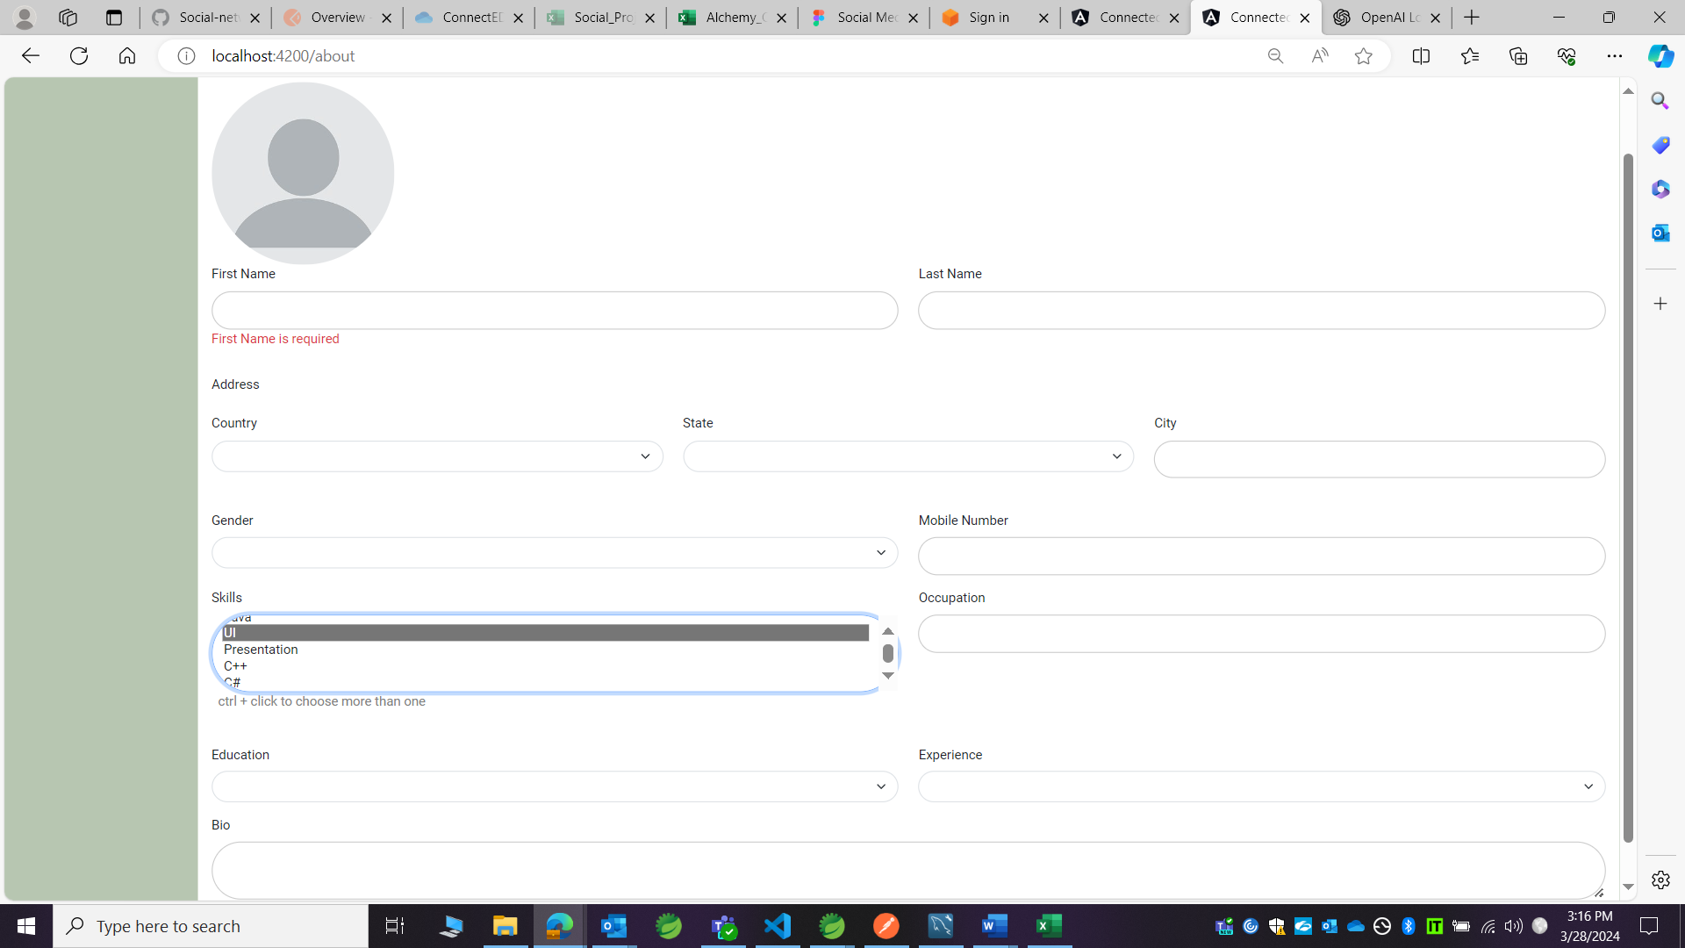

3.Error message is not displaying when more than 10 digits are entered in mobile number field.

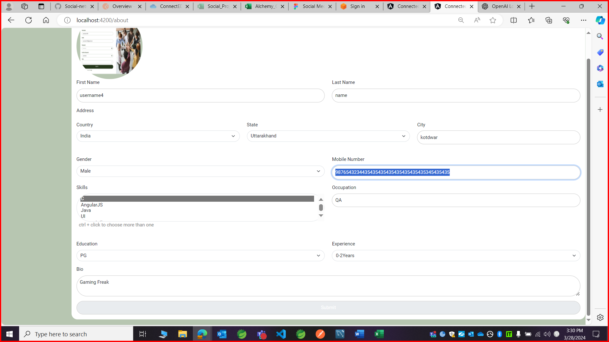

4.First name, last name and city fields are accepting digits, but they should not

5.Occupation field is accepting special characters, but it should not.

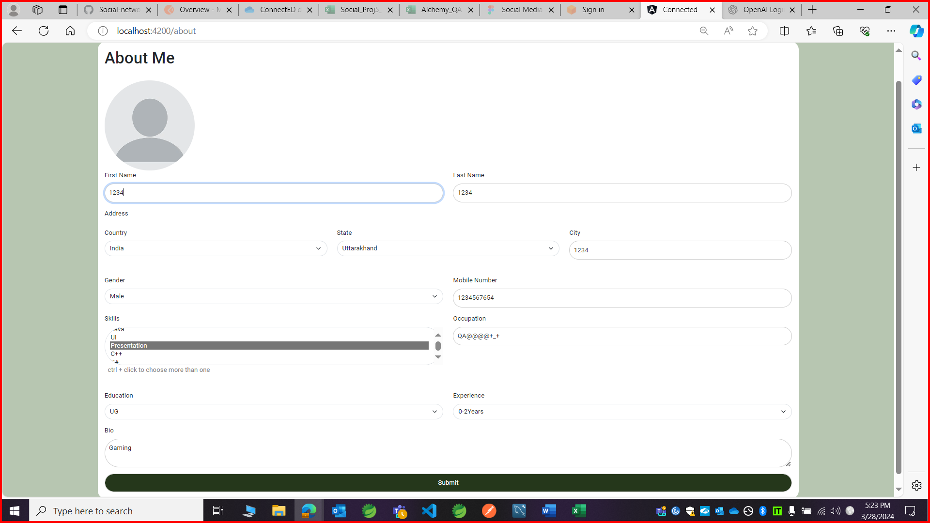

6.

* Either country field should be pre-filled and non-editable or in dropdown multiple countries should be there.
* State dropdown should not be visible until country is selected.

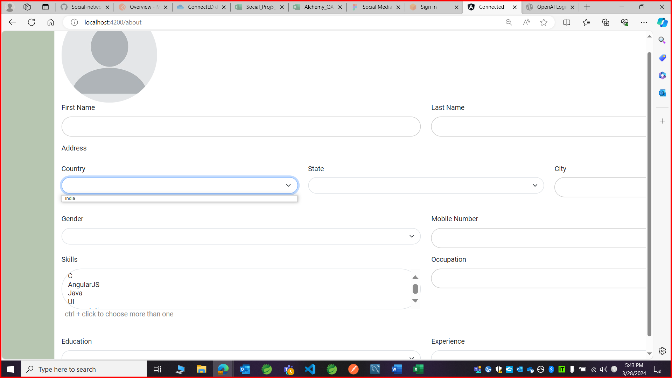

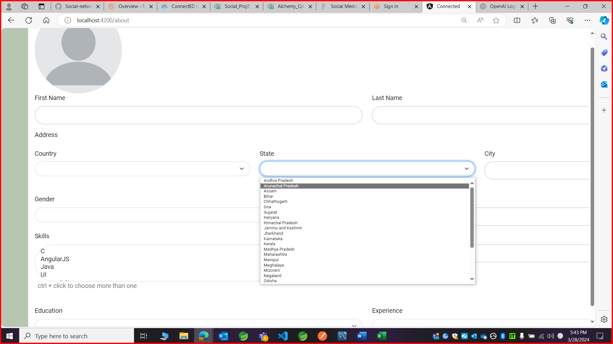

7.After filling all details except skills and profile photo, submit button is still getting enabled, but it should not, but user is not able to submit the form unless he fills all details including profile photo.

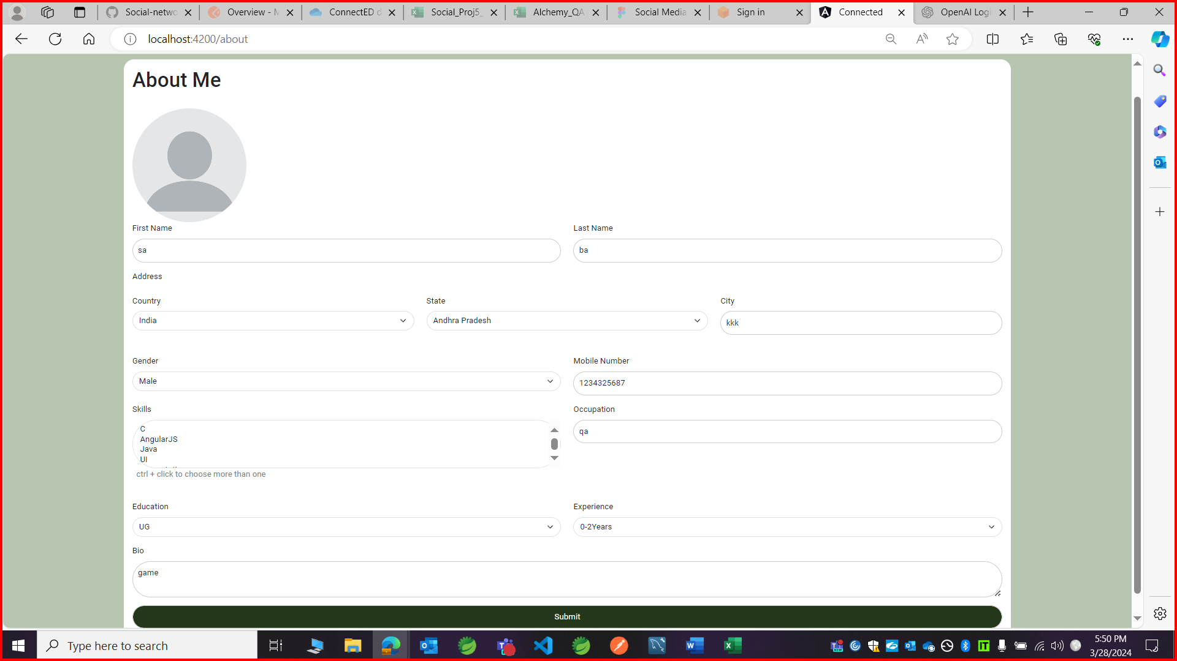

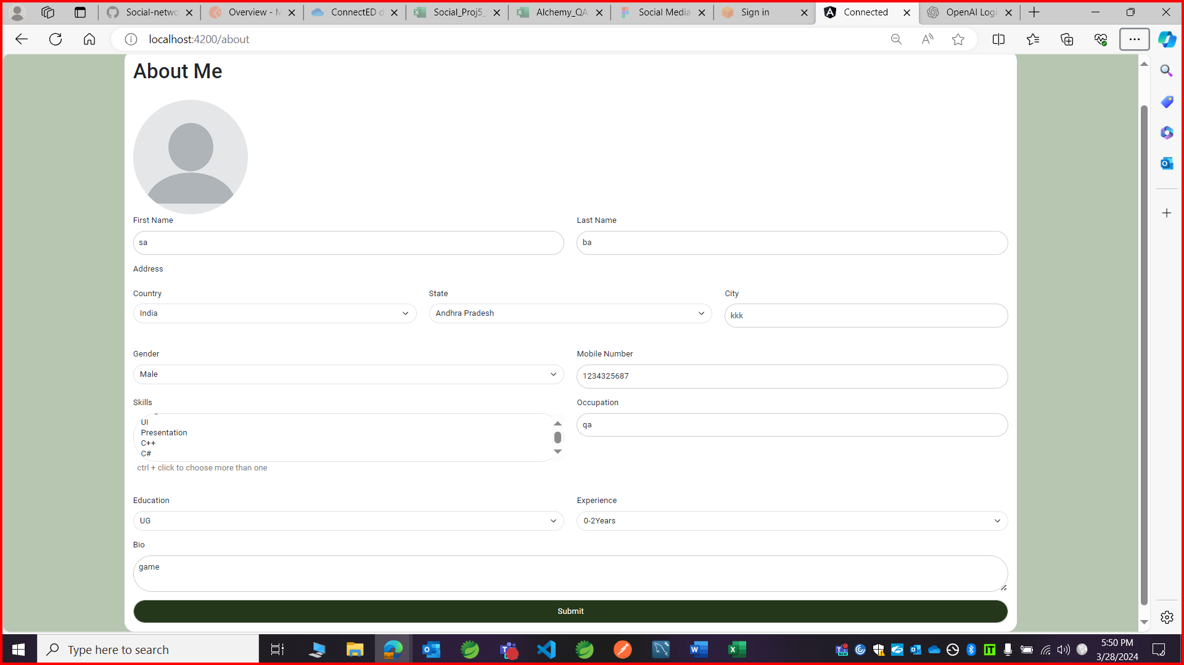

8.After submitting user’s profile data, in the profile page ‘_’ (underscore) is displaying for city tamil nadu and there is no space after the ‘,’ commas.

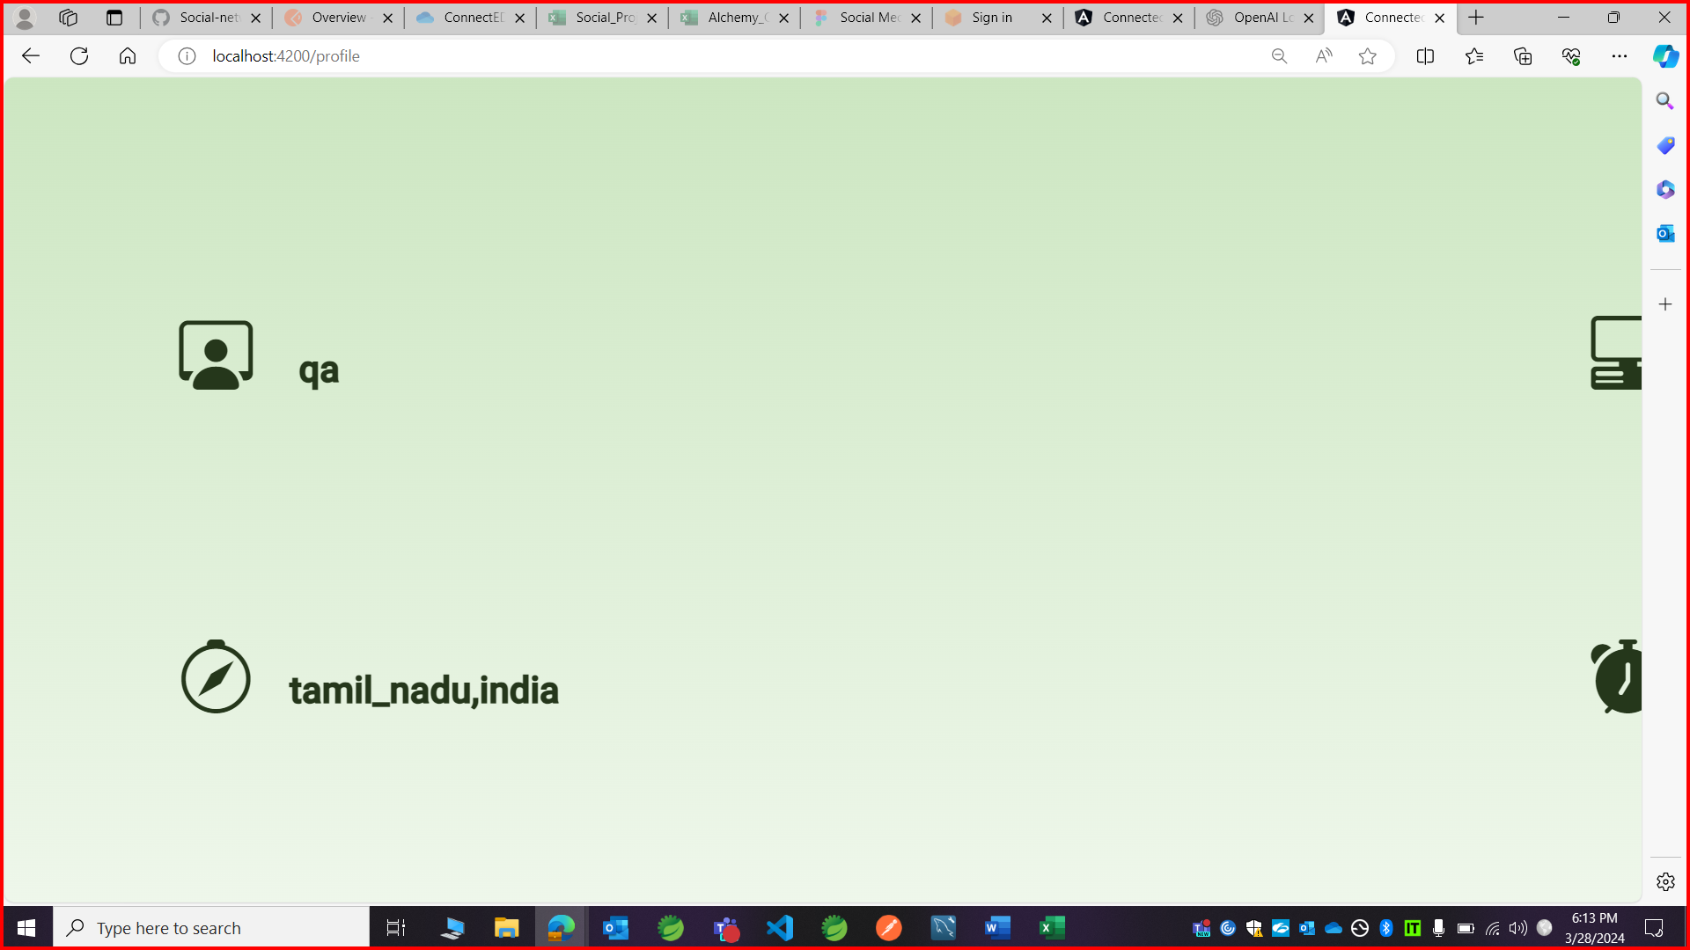

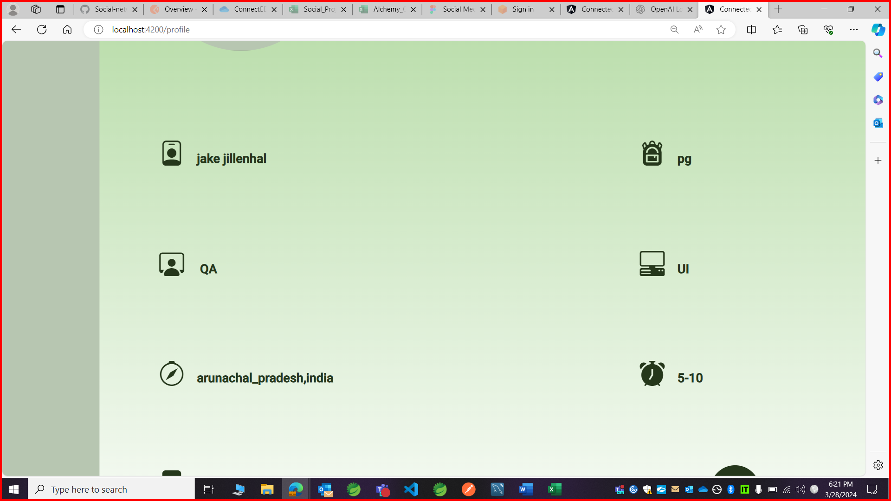

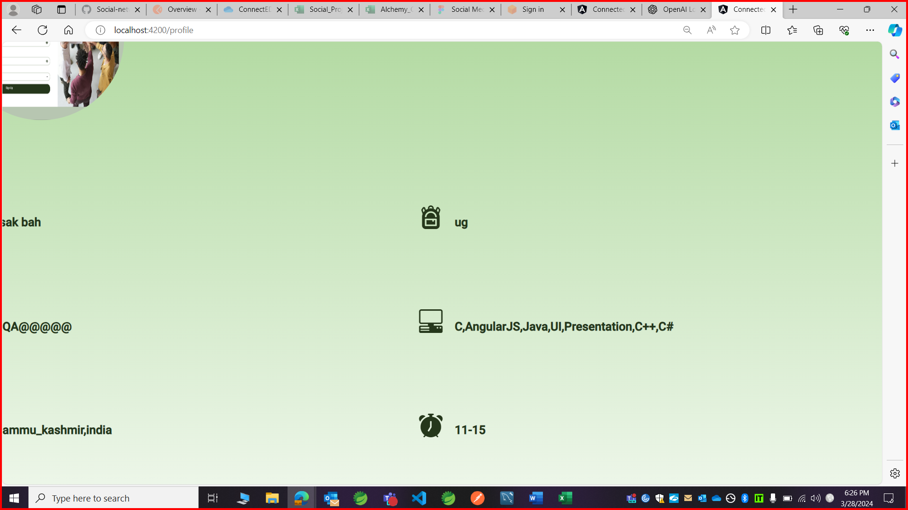

9.Details filled in the ‘About me’ page are displaying in small case in the profile page.

